Training Report

On

**Python for Data Science and Machine Learning**

For partial fulfilment of the requirement for award

Of

**Diploma in Computer Science Engineering**



**Guru Nanak Dev Polytechnic College, Gill Park**

**(Ludhiana)**

**MONTH & YEAR**

i

**CERTIFICATE**

**Certified that this project report “……….TITLE OF THE PROJECT……………..” is the bonafide work of “…………..NAME OF THE CANDIDATE(S).…………” who carried out the project work under my supervision.**

|  |  |  |
| --- | --- | --- |
| **<< Name>>**  **Guide** | **<< Name>>**  **Head of the Department** | **<< Name>>**  **Principal** |

**NAME OF YOUR DEPARTMENT**

**NAME OF YOUR INSTITUTE**

**NAME OF UNIVERSITY**

ii

**ACKNOWLEDGEMENT**

I would like to express my special thanks of gratitude to my project guide << Name of guide>> as well as our principal << Name of guide>> who gave me the golden opportunity to do this wonderful project on the topic << project title >>, which also helped me in doing a lot of research and i came to know about so many new things I am really thankful to them.

Secondly I would also like to thank my parents and friends who helped me a lot in finalizing this project within the limited time frame.

|  |  |
| --- | --- |
| Date : | << Your Name >> |
| Place : | << Roll no >> |
|  | << Class >> |

iii

**TABLE OF CONTENTS**

|  |  |  |
| --- | --- | --- |
|  | **TITLE** |  |
|  | **ABSTRACT** | **iii** |
|  | **LIST OF TABLES** | **v** |
|  | **LIST OF FIGURES** | **vi** |
|  | **LIST OF SYMBOLS AND ABBREVIATIONS** | **vii** |
| **1.0** | **INTRODUCTION** | **1** |
|  | 1.1 Sub section | 1 |
|  | 1.2 Sub section | 1 |
| **2.0** | **LITERATURE REVIEW** | **2** |
|  | 2.1 Sub section | 2 |
|  | 2.2 Sub section | 2 |
| **3.0** | **METHODOLOGY** | **3** |
|  | 3.1 Sub section | 3 |
|  | 3.2 Sub section | 3 |
| **4.0** | **EXPERIMENTATION** | **4** |
|  | 4.1 Sub section | 4 |
|  | 4.2 Sub section | 4 |
| **5.0** | **RESULT AND DISCUSSION** | **5** |
|  | 5.1 Sub section | 5 |
|  | 5.2 Sub section | 5 |
| **6.0** | **CONCLUSION** | **6** |
| **7.0** | **FUTURE SCOPE** | **7** |
|  | **REFERENCES** | **8** |

**ABSTRACT**

Abstract should be one page synopsis of the project report typed double line spacing, Font Style Times New Roman and Font Size 12.

vi

**LIST OF TABLES**

|  |  |  |
| --- | --- | --- |
| **Table No.** | **Title** | **Page No.** |
| Table 1.1 | Name of the table | 1 |
| Table 2.1 | Name of the table | 2 |
| Table 3.1 | Name of the table | 3 |

vi

**LIST OF FIGURES**

|  |  |  |
| --- | --- | --- |
| **Figure No.** | **Title** | **Page No**. |
| Figure 1.1 | Name of the figure | 1 |
| Figure 1.1 | Name of the figure | 2 |
| Figure 1.1 | Name of the figure | 3 |

viii

**LIST OF SYMBOLS AND ABBREVIATIONS**

|  |  |
| --- | --- |
| **Symbol** | **Explanation** |
| $ | Dollar |
|  |  |

ix

1. **INTRODUCTION**

This chapter should contain brief background information about the project, the methodology implemented for problem-solving, and the outlines of the results and future scope of the project. It rarely contains drawings and graphical illustrations.

1. **LITERATURE REVIEW**

It evaluates the current work with the previous one. It depicts the current implementations that overcome the previous problems and limitations of the project, and draws the attention and focus on the foreknowledge work that would be conducted based on the ongoing work at present. It must be clear and simple to understand.

1. **METHODOLOGY**

Essentially, a methodology is a collection of methods, practices, processes, techniques, procedures, and rules

Explain your methodological approach.

Describe your methods of data collection and/or selection.

Describe your methods of analysis.

Evaluate and justify your methodological choices.

Table 3.1 : Title of the table

|  |  |  |
| --- | --- | --- |
| **Heading** | **Heading** | **Heading** |
| Data | Data | Data |
| Data | Data | Data |

Figure 3.1 : Title of the image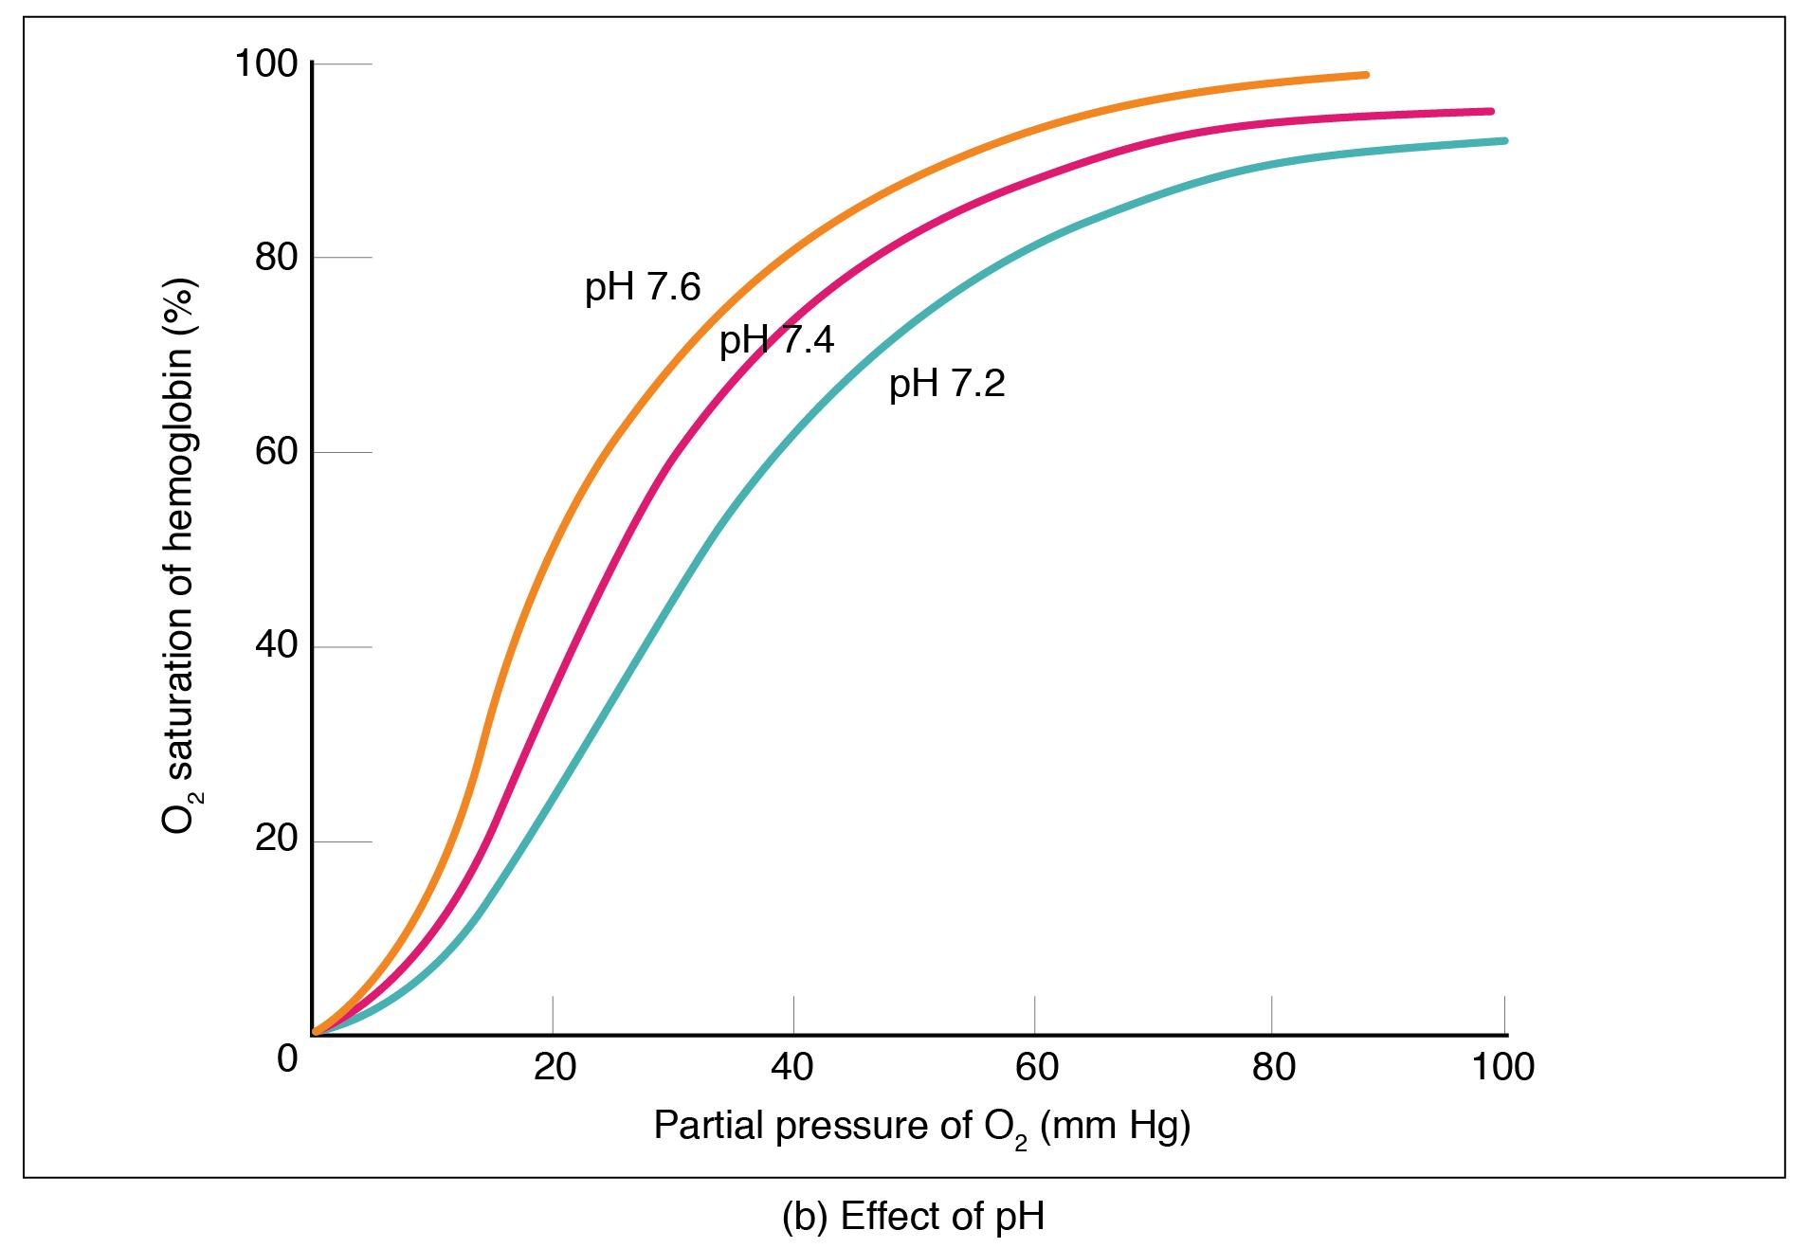

1. **EXPERIMENTATION**

Write the experimental procedure like a step-by-step recipe for your science experiment. A good procedure is so detailed and complete that it lets someone else duplicate your experiment exactly!

1. **RESULT AND DISCUSSION**

This section should be written in the present tense. The Discussion section needs to follow from your results and relate back to your literature review.

Interpret and explain your results.

Answer your research question.

Justify your approach.

Critically evaluate your study.

1. **CONCLUSION**

The conclusion and recommendations part summarizes the whole report by highlighting all the chapters and their significance and the importance of the project and the achievements.

1. **FUTURE SCOPE**

Scope for future development if any

**REFERENCES**

1. Shin, K.G. and Mckay, N.D. (1984) ‘Open Loop Minimum Time Control of Mechanical Manipulations and its Applications’, Proc.Amer.Contr.Conf., San Diego, CA, pp. 1231-1236.